Improving the practical Space and Time Efficiency of the Shortest-Paths Approach to Sum-of-Pairs Multiple Sequence Alignment
Sandeep K. Gupta, John D. Kececioglu
Journal of Computational Biology, Volume: 2, Number: 3,1995, pp. 459-472
Abstract
The MSA program, written and distributed in 1989, is one of the few existing programs that attempts to find optimal alignments of multiple protein or DNA sequence. The MSA program implements a branch-and-bound technique together with a variant of Dijkstra’s shortest paths algorithm to prune the basic dynamic programming graph..
- Introduction
Some other programs : AMULT, DFALIGN, MULTAL, TULLA, CLUSTAL V and MWT. The version of multiple sequence alignment that MSA sloves can be formulated as a single-source, single-destination shortest-path problem on a meshshaped dynamic graph.
- Definitions and the Carrillo-Lipman method
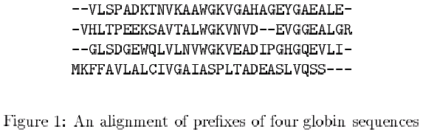

Sum of pairs multiple sequence alignment problem:
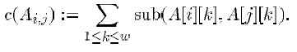
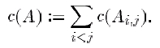

The MSA program sloves a variation where each pariwise alignment cost Is multiplied by a weight, denoted by scale(Si, Sj), with weights chosen from an evolutionary tree of the input sequence.

Define a lower bound L as the weighted sum
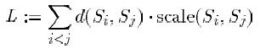

U – L := δ
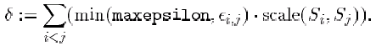
For example, in the alignment of Figure 1 the first two edges are
<0,0,0,0> -- <0,0,0,1> -- <0,1,0,2> -- <1,2,1,3> -- <2,3,2,4>
- Results
The data sets presented by McClure et al. They compare 4 data sets consisting of 12 globin sequence, 12 kinase sequences 12 protease sequences, and 12 RH sequences respectively.
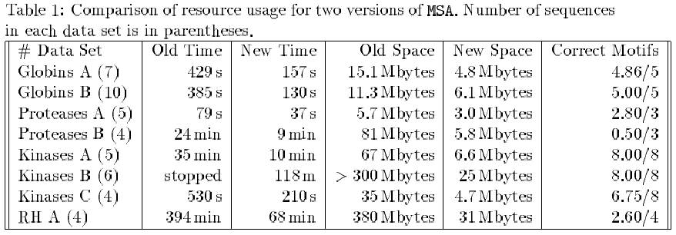
Created by: Chia-Mao Huang
Date: May 22, 2000

